VISVESVARAYA TECHNOLOGICAL UNIVERSITY JNANA SANGAMA, BELAGAVI-590018

A Mini-Project Report on
“IOT BASED AUTOMATIC GATE
CONTROLLING SYSTEM”

Submitted In partial fulfilment for the award of degree of

BACHELOR OF ENGINEERING
In

ELECTRONICS AND COMMUNICATION ENGINEERING
Submitted by

DURGAMMA 3BR22EC036
G ARUN KUMAR H 3BR22EC037
KAUSHIK S 3BR22EC073

Under the guidance of
DR.NASEERUDDIN
(Asst.HOD & Asst. Professor)

 | BALLARI INSTITUTE OF TECHNOLOGY & MANAGEMENT  Autonomous Institute under VTU,Belagavi  NAAC A⁺ Accredited Institution  (Recognized by Govt. of Karnataka, approved by AICTE, New Delhi & Affiliated to Visvesvaraya Technological University, Belagavi)  "Jnana Gangotri" Campus, No.873/2, Bellary-Hosapete Road, Allipur, Ballari-583 104 (Karnataka) (India)  08392 – 237100 / 237190, Fax: 08392 – 23719 | 

2024-2025

VISVESVARAYA TECHNOLOGICAL UNIVERSITY

Belagavi, Karnataka
B

BASAVARAJESHWARI GROUP OF INSTITUTIONS
BALLARI INSTITUTE OF TECHNOLOGY & MANAGEMENT
NAAC Accredited Institution*
(Recognized by Govt. of Karnataka, approved by AICTE, New Delhi & Affiliated to Visvesvaraya Technological University, Belagavi) "Jnana Gangotri" Campus, No.873/2,Ballari-Hosapete Road, Near Allipur, Ballari-583 104 (Karnataka)
(India) Ph.: 08392 – 237100 / 237190, Fax: 08392 – 23719

DEPARTMENT OF ELECTRONICS AND COMMUNICATION ENGINEERING

CERTIFICATE
Certified that the Mini-Project work entitled “IOT BASED AUTOMATIC GATE CONTROLLING SYSTEM”, is a bonafide work carried out DURGAMMA (3BR22EC036), G ARUN KUMAR H (3BR22EC037), KAUSHIK S (3BR22EC073) the bonafide students of Ballari Institute of Technology and Management in partial fulfilment for the award of degree of Bachelor of Engineering in ELECTRONICS AND COMMUNICATION ENGINEERING of the Visvesvaraya Technological University, Belagavi during the academic year 2024-2025. It is certified that all corrections/suggestions indicated for internal assessment have been incorporated in the report deposited in the departmental library. The report has been approved as it satisfies the academic requirements
in respect of Mini-Project work prescribed for the said Degree.

Dr. Naseeruddin | Dr. Girija vani | Dr. Sadyojatha K M
Project guide | Project Co-Ordinator | HOD, Dept. of ECE

External Viva
Name of the Examiner Signature with date
1.
2.

Acknowledgment

In the accomplishment of completion of the mini project on “Iot Based Automatic Gate Controlling System”, We would like to convey our special gratitude to Project Guide Dr.Naseeruddin, Dr. Girija Vani, Dr. Sadyojatha K M HOD of E&CE Dept., BITM, Bellary.

Your valuable guidance and suggestions helped us in various phases of the completion of our mini project. We will always be thankful to you in this regard.

We are also grateful to all the Mini Project Coordinators and E&CE Faculty members for their support in carrying out the mini project.

We are also indebted to all the lab instructors, store keepers and the supporting staff.

We would also like to extend our deep appreciation to all our group members, without their support and coordination we would have not completed this mini project.

We also thank our parents for providing all the necessary support in carrying out this mini project.

Names USN
- Durgamma 3BR22EC036
- G Arun Kumar H 3BR22EC037
- Kaushik S 3BR22EC073

ABSTRACT

SL.NO | Chapter | Figure | Page No
1. | Abstract | - | 4
2. | Introduction | - | 5-6
3. | Review of literature | 3.1 | 7
4. | Methodology and implementation | 4.1.1  4.1.2  4.1.3  4.1.4  4.1.5  4.2.1  4.2.2  4.5.1  4.6.1 | 8-18
5. | Results and Discussions | - | 19-20
6. | Conclusion And Future Scope | - | 21-22
7. | References | - | 23

ABSTRACT

This project is to design and develop low cost auto gate system for house, Building, Collages, etc. Automatic gate
is one of the most preferable domestic intended to provide easy access to gate home. There are three types of
automatic gate mechanism, such as sliding, screw drive piston and swing cubic underground. Designs available
today are limited only to the three types mentioned. Products available in the market are quite pricy, even
when installation and maintenance cost is not yet been considered. Most of the products available in our
country are imported from foreign country.

In this final year project work, we attempt to construct a small and simple model of low cost Automatic Gate
System, which uses a power motor, circuitry to move the gate. The primary aim of this project is to learn in
details about how the automatic gate system works and to understand the concepts involved. The secondary
aim is to fabricate a simple model to show how the system works. The main activities involved in this
project are the research done on how the automatic gate works.

This system leverages Internet of Things (IoT) technology to remotely monitor and control gate operations
via mobile devices or web applications. By integrating sensors, motors, and communication modules, the
system allows for automated gate opening and closing based on predefined conditions such as proximity
detection or authorized access.
Chapter-1

INTRODUCTION

The advancement of Internet of Things (IoT) technologies has revolutionized various sectors, providing enhanced control, automation, and connectivity. One such application of IoT is in the development of automatic gate controlling systems, which have become an essential component in securing residential, commercial, and industrial premises. Traditional gate control systems rely heavily on manual operation or RFID controls, leading to inefficiencies and security vulnerabilities.

IoT-based automatic gate controlling systems address these challenges by introducing automation, RFID TAG access, and real-time monitoring, enhancing both security and convenience. This system integrates a range of IoT devices, including sensors (such as infrared or ultrasonic), microcontrollers, communication modules, and actuators (for gate movement). Through this interconnected network, users can monitor the opening and closing of gates using,
Ultrasonic sensor ,RFID ,ultrasonic sensor, servo motor,significantly improving the ease of access.

Additionally, the system can be programmed to respond to specific triggers like proximity detection, user authentication, or scheduled operations, ensuring smooth and secure gate management.

This makes IoT-based gate control systems a modern, scalable solution suitable for a wide range of applications, from residential homes to large-scale industrial setups, offering enhanced efficiency, cost-effectiveness, and security.

Chapter-1.1
- Problem Statement:
  - In modern homes, the convenience and security of entry points, such as gates, are paramount. Traditional manual gate systems require physical interaction, which can be inconvenient, especially when carrying items, during inclement weather, or for individuals with mobility challenges
  - Additionally, unauthorized access can pose significant security risks. Homeowners need a reliable, efficient, and secure method to control and monitor their gates, ensuring the ease of access and enhanced security.

Proposed Solution:
  - An IoT-based Automatic Gate Controlling System for Homes can be developed to address these challenges. This system will allow homeowners to control their gates via a mobile application, providing convenience and improved security.
  - The system will utilize various IoT technologies, including sensors, microcontrollers, and wireless communication, to automate gate operations.

Chapter-1.2 Objectives:
- Automate the opening and closing of gates based on specific conditions (such as vehicle detection, time schedules, or user commands).
- Improve security by allowing access control through user authentication, such as RFID, biometric scans, or mobile app-based authentication.
- Integrate the gate control system with other IoT devices like surveillance cameras, alarms, or motion sensors to enhance monitoring.
- Optimize energy consumption by ensuring that the gate opens only when necessary and operates efficiently.
- Provide real-time notifications to users when the gate is operated, or when unauthorized access is detected.
- Reduce the overall cost of manual gate operations and enhance security without the need for physical personal.
- Chapter-2
LITERATURE OF REVIEW

"IoT Based Automated Gate Control System Using Arduino and RFID" (2021)

This study explores the integration of RFID and IoT with Arduino to create an automated gate control system. It discusses how RFID tags can be used for secure access control, and Arduino acts as the central unit that processes RFID data and controls the gate. The IoT feature allows remote monitoring and control through a smartphone, making the system highly efficient and user-friendly.
"RFID Based Security System with IoT and Arduino" (2020)

The authors propose a smart security system where RFID is integrated with Arduino and IoT technology to enhance security by controlling gate access. It emphasizes remote control and real-time monitoring via web or mobile applications, providing a high level of convenience and security for users. The system uses cloud computing for data storage and access logging.
"Smart IoT-Based Gate Control Using RFID and Arduino" (2019)

This research presents a smart gate system that uses an Arduino microcontroller to interface with RFID tags. The IoT application enables users to control and monitor the gate from a distance. The paper highlights the use of a mobile app for notifications and remote operations, thus increasing automation and reducing human intervention in gate management.
"Design and Implementation of RFID-Based Gate Control System" (2018)

the architecture of an RFID-based gate control system with Arduino as the microcontroller. The RFID system ensures secure entry and exit by verifying authorized personnel based on RFID tag data. The IoT connection allows the system to be controlled remotely through a smartphone application, offering both security and automation.
"IoT Based Automatic Gate System with RFID Technology" (2017)

The study covers the design and implementation of an automatic gate system using Arduino and RFID. The paper discusses the basic functioning of the system, where an RFID reader is used to scan the card and open the gate. The IoT feature allows tracking and control of gate operations, making it useful for parking lots, homes, and offices.
"Arduino-based IoT-Enabled Access Control System" (2016)

In this research, the authors discuss the use of Arduino in IoT-based access control systems. They highlight how RFID and Arduino can be combined for automatic gate control and user authentication. The system sends data to a cloud platform, allowing the administrator to monitor gate activity and control access remotely.
Chapter-3

METHODOLOGY AND IMPLEMENTATION:
The methodology for developing an IoT-based automatic gate controlling system using RFID (Radio Frequency Identification) involves a systematic process that integrates various technologies, including RFID, IoT, and automation to enhance access control systems. Below is a structured methodology for implementing this
system
Chapter-4.1:
Hardware Components:

1.RFID Tag Registration : Authorized RFID tags (for vehicles or personnel) are registered in the system’s
database. This database can be stored locally in the microcontroller’s memory or in the cloud (IoT platform).

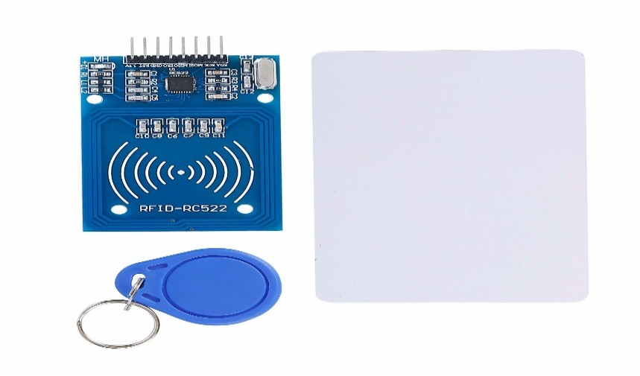

Fig 4.1.1 RFID KIT

By integrating RFID technology with IoT, this automatic gate control system provides a highly

secure and efficient access solution. It allows for seamless entry through RFID tags, provides

real-time monitoring, and supports remote control, making it ideal for applications such as

residential complexes, industrial areas, or offices.

2.SERVO MOTOR
Servo motors are used to control the gate’s motion by turning a shaft or rotating an arm. This can be coupled with a mechanical arm, linkage, or even directly with a gate that moves in a specific direction (e.g., swing or slide gates). The servo motor’s ability to precisely control angles allows it to open and close the gate accurately without overshooting.

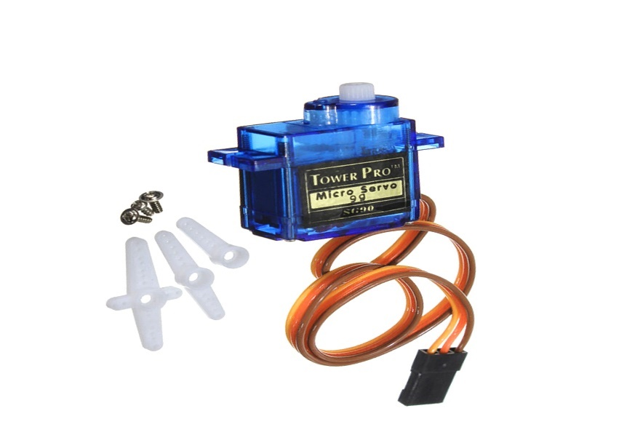

Fig 4.1.2 SERVO MOTOR

Specifications: servo motor in iot based automatic gate controlling system

Torque defines the rotational force required to move the gate. A higher torque is needed for larger or
heavier gates, while a lower torque may suffice for smaller gates. The servo motor should be able
to provide enough torque to easily open and close the gate without stalling or overloading.

3. JUMPER WIRE:
Jumper wires are short electrical wires used in electronics and prototyping to connect components on a breadboard or
between different parts of a circuit. These wires are commonly used in electronics projects, particularly in Arduino
or Raspberry Pi prototyping, where quick, temporary connections need to be made.

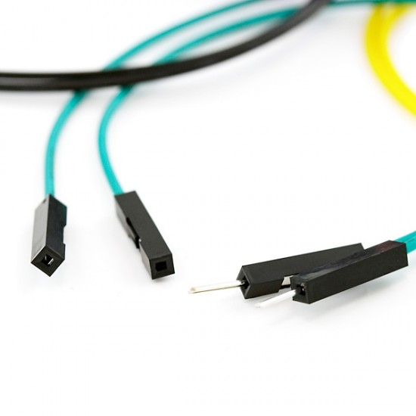

Fig 4.1.3 JUMPER WIRE

They provide the flexibility to create connections between various components without
permanent soldering, enabling easy testing and adjustments. Properly selecting the right
jumper wire based on length, pin type, and wire gauge ensures smooth circuit design
and implementation.

4.BREAD BOARD:
A breadboard is a crucial tool for prototyping electronic circuits. In an IoT-based automatic gate controlling system, a breadboard serves as the platform to build, test, and modify the circuit before making it permanent. The breadboard allows easy connections and disconnections of components such as the microcontroller, RFID module, servo motor, and other sensors that interact in the system.

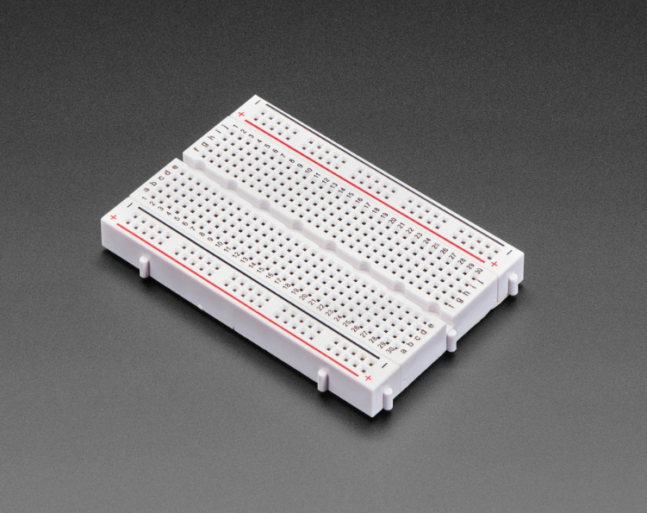

Fig 4.1.4 BREAD BOARD

5.ULTRASONIC SENSOR
An ultrasonic sensor is a device that measures the distance to an object by using ultrasonic sound waves. It consists of two main components: a transmitter that emits ultrasonic sound waves and a receiver that detects the reflected waves (echo) after they bounce off an object.
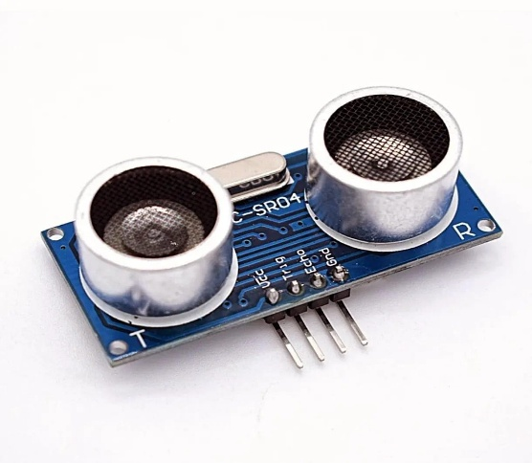
Fig 4.1.5 ultrasonic sensor

6.Ardunio

Arduino is an open-source electronics platform based on simple software and hardware. It is widely used for building digital devices and interactive objects that can sense and control the physical world. Arduino is favored for its ease of use, flexibility, and low cost, making it a popular choice for both beginners and advanced users in the fields of robotics, automation, IoT (Internet of Things), and other electronics projects.

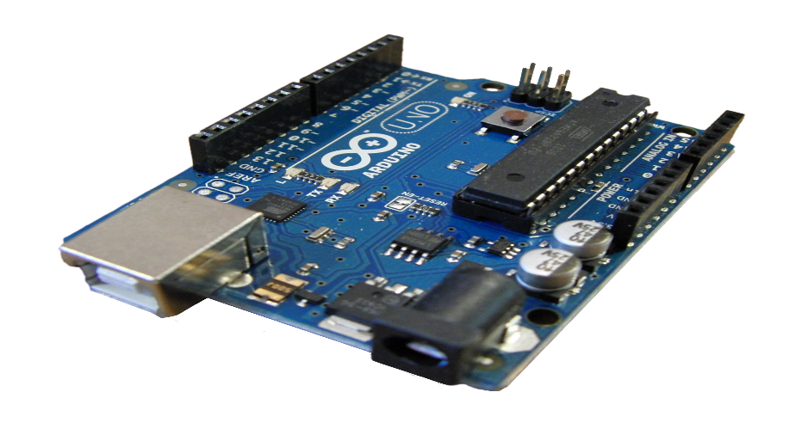

Software Components:

    - Arduino IDE:
      - Role: The Arduino Integrated Development Environment (IDE) is used for writing and uploading code to the Arduino microcontroller. The program continuously monitors the data from the MQ6 sensor and activates system components based on predefined conditions.
      - Programming Language: The system is programmed using Arduino C++, with simple algorithms to manage the sensor readings and system responses.

Algorithm Design:
      - Initialization:
Initialize all components: Arduino, MQ-5 sensor, SIM900A GSM module, buzzer, servo motor, and exhaust fan.
Set communication baud rate for GSM module and establish readiness of sensors.
  - Start Monitoring:
Continuously read the gas concentration from the MQ-5 sensor's analog output.
  - Check Gas Levels:
If the gas concentration exceeds the predefined threshold: Activate the buzzer for an audio alert. Turn on the exhaust fan using the relay module to disperse the gas.
Trigger the servo motor to perform a safety action (e.g., closing a gas valve).
  - Send SMS Alert:
Use the GSM module to send an alert SMS to a predefined mobile number. Include the current gas concentration level and location (if GPS module integrated).
  - Monitor Safety Actions:
Continuously monitor gas levels to ensure they return to a safe range. If the gas level remains high:
Retry sending SMS alerts at intervals.
Keep the exhaust fan and safety mechanisms active.
  - Reset System:
When gas levels return to normal: Turn off the buzzer and exhaust fan. Reset the servo motor to its default position.
Prepare the system for further detection.

Chapter-4.2:

METHODOLOGY :

Fig 4.2.1 Methodology
FLOW CHART:

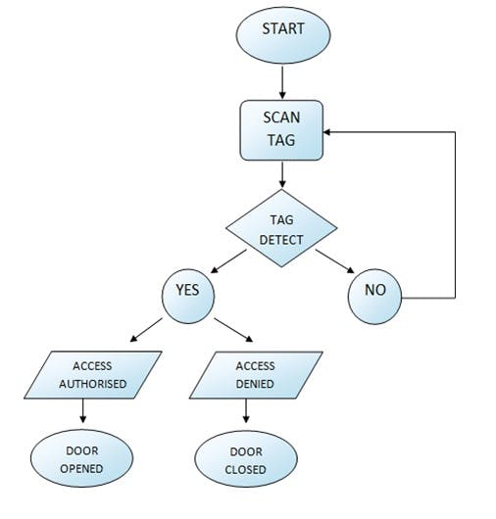
Chapter-4.3:
System Flowchart and Operation:

This flowchart outlines the functioning of an RFID-based access control system in detail:
1. Start
The system initializes and is ready to operate. It begins by actively scanning for RFID tags presented to the reader.

2. Scan Tag
The RFID reader continuously scans for a tag. A tag must be presented to the reader by the user for further action.

3. Tag Detect
The system checks whether an RFID tag has been detected:
- If no tag is detected:
  - The system loops back to scanning for a tag, remaining in the "Scan Tag" stage.
- If a tag is detected:
  - The process proceeds to validate the tag.

4. Validate Access
Once a tag is detected, the system verifies it against its database or authorized list:
- Access Authorized:
  - If the tag matches an authorized entry, the system grants access. This results in the door being opened for the user.
- Access Denied:
  - If the tag does not match any authorized entries, access is denied, and the door remains closed.

5. Loop
After granting or denying access, the system loops back to scanning for the next RFID tag, ensuring continuous operation.
Explanation of Key Components:
- Tag Detection: The RFID reader checks for the presence of an RFID tag in its proximity. Tags typically contain unique identification data.
- Authorization Check: The system cross-checks the tag's ID with a predefined database of authorized IDs. This ensures only valid users are granted access.
- Door Control: Based on the outcome of the authorization check, the system either opens or keeps the door closed.

1. Components Required
- RFID Reader Module (e.g., MFRC522)
- RFID Tags (e.g., keycards or key fobs)
- Microcontroller (e.g., Arduino Uno, ESP32, or Raspberry Pi)
- Servo Motor (to simulate door opening and closing)
- Power Supply (USB or battery)
- Breadboard and Jumper Wires
- LEDs (optional, to indicate access granted or denied)
- Buzzer (optional, for sound indication)

2. Circuit Diagram
- Connect the RFID reader to the microcontroller as per the reader's specifications (e.g., SPI or I2C interface).
- Connect the servo motor to a digital pin of the microcontroller for door control.
- Use LEDs and/or a buzzer for visual and audio feedback.
Example connection for MFRC522 to Arduino Uno:
RFID Pin | Arduino Pin
VCC | 3.3V
GND | GND
RST | Digital Pin 9
SDA | Digital Pin 10 (SS)
SCK | Digital Pin 13
MOSI | Digital Pin 11
MISO | Digital Pin 12

Chapter-4.5: Circuit Connection:
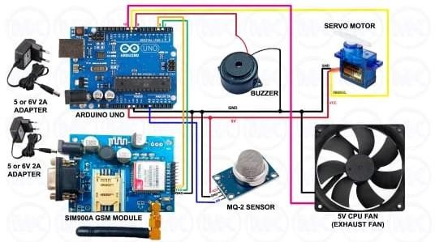
Fig 4.5.1 Circuit Connection

Code Used In Implementation:
#include <Servo.h>
#define gas_sensor A0 //MQ-2 Sensor A0 pin #define buzzer 8 //Buzzer red wire
#define fan 10 //CPU Fan red wire

#include <SoftwareSerial.h>
SoftwareSerial sim900A(2, 3);//arduino pin 2 connected to TX pin of GSM module
//arduino pin 3 connected to RX pin of GSM module
//arduino GND pin connected to GND pin of GSM module int sensor_value;
Servo servo;
String phoneNumber = "+91XXXXXXXXXX"; //change mobile number here to receive call/sms
String message = " ALERT!! \nGAS LEAKAGE DETECTED \nREGULATOR TURNED OFF";
//change content if required
15

void setup() { Serial.begin(9600); sim900A.begin(9600); delay(1000);
sim900A.println("AT+CMGF=1"); delay(1000);
pinMode(buzzer, OUTPUT); pinMode(fan, OUTPUT);
servo.attach(9); //servo motor signal pin attached to arduino pin 9 servo.write(12); //regulator on
}

void loop() {
sensor_value = analogRead(gas_sensor); Serial.println(sensor_value);
if (sensor_value > 650) // change this value according to sensitivity of gas
{
digitalWrite(buzzer, HIGH); digitalWrite(fan, HIGH); servo.write(140); delay(1000);
servo.detach(); sendSMS(phoneNumber, message); makeCall(phoneNumber); servo.attach(9);
servo.write(12);
}

else
{
digitalWrite(buzzer, LOW); digitalWrite(fan, LOW); servo.write(12);
}
delay(50);
}
void sendSMS(String phoneNumber, String message) { sim900A.print("AT+CMGS=\"" + phoneNumber + "\"\r"); delay(1000);
sim900A.print(message); delay(1000); sim900A.print((char)26); delay(1000); delay(3000);
}
void makeCall(String phoneNumber) { sim900A.println("ATD" + phoneNumber + ";"); delay(20000);
sim900A.println("ATH"); delay(1000);
}

OUTPUT
Chapter-4.6:
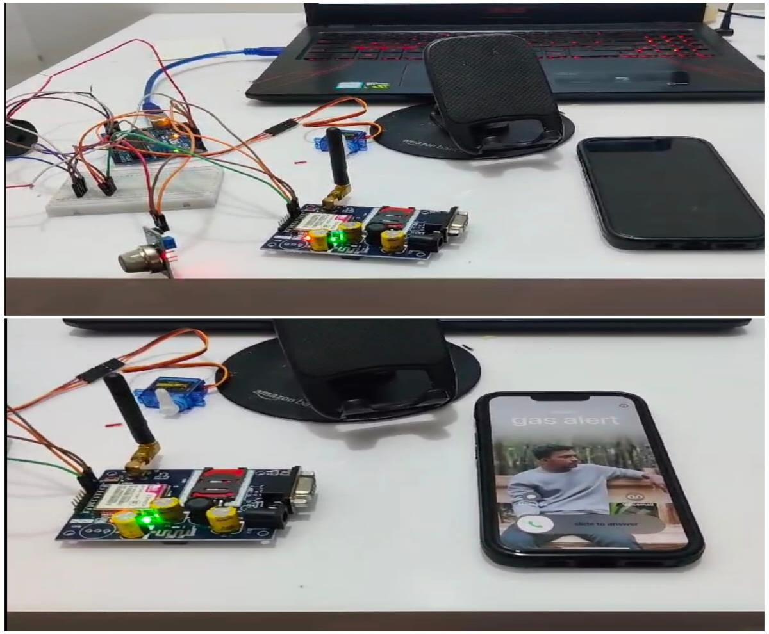
Fig 4.6.1 Output With Call and Alert Message

RESULTS AND DISCUSSIONS

Chapter-5

Results

Real-Time Monitoring:

Real-time monitoring via the Wi-Fi module allows users to receive notifications and alerts, ensuring
that they are always informed about the gate’s operation and security status. This feature increases
security and awareness.

Cost and Time Efficiency:

Implementing an IoT-based system with Wi-Fi connectivity eliminates the need for additional
infrastructure such as complex wired control systems.

: User-Friendly Interface

The user interface provided by mobile apps or web platforms is intuitive and user-friendly, making

it easy for users to interact with the system. Users can monitor gate status, adjust settings, and

receive notifications without needing technical expertise

Improved User Experience:

By using a Wi-Fi module, the system becomes more responsive and quicker in terms of control and feedback. Latency is reduced, allowing almost immediate reaction from the system when a command is issued.

Discussion

Wi-Fi Module (e.g., ESP8266 or ESP32):

Enables wireless communication between the gate and the user’s smartphone or web application.

Actuators (Motors):

These are used to physically open and close the gate.

Power Supply:

The system requires a stable power source, often integrated with low-power components to minimize energy consumption.

Energy Efficiency:

IoT-based gate control systems are typically designed with energy efficiency in mind. Components like

low-power Wi-Fi modules and sensors minimize energy consumption.

.

CONCLUSION AND FUTURE SCOPE
Chapter-6

Conclusion

In conclusion, IoT-based automatic gate controlling systems represent a significant leap forward in

automation, security, and convenience. By integrating IoT technology, these systems offer real-time

monitoring and remote control, enhancing both accessibility and user experience. They provide a

range of benefits, including increased security, energy efficiency, and cost savings, while offering

seamless integration with other smart devices and systems.

The key advantages of IoT-based automatic gate control systems include enhanced security through

advanced access controls (such as biometrics and AI-based surveillance), the ability to automate gate

operations for convenience, and the capacity to generate real-time alerts and data analytics for better

decision-making.

Future Scope:

Autonomous Vehicle Integration:

As autonomous vehicles become more widespread, IoT-based gates will interact seamlessly with
self-driving cars to open and close without human intervention.

Global Accessibility and Scalability:

As IoT technologies become more widely adopted, global accessibility and scalability will
be key considerations.

Collaborative IoT Systems:

Future systems will be part of larger collaborative IoT networks, where gates can communicate with other devices and platforms to provide enhanced services.

Seamless Multi-Platform Integration:

IoT-based gate systems will increasingly support integration with a variety of devices, platforms, and interfaces, creating a seamless user experience.

Edge Computing for Real-Time Processing:

Edge computing will enable gate systems to process data locally instead of relying on cloud servers, resulting in faster and more efficient operations

Energy Efficiency and Sustainability:

The future of IoT-based gate systems will focus more on energy efficiency and sustainability.

REFERENCES

CHAPTER-7:
- "Design and Implementation of an Economic Gas Leakage Detector" Authors: Mahalingam B., T.H.Mujawar, and M.S. Kasbe
Published in: 2012
Description: Discusses the development of a cost-effective system for LPG gas leak detection using gas sensors and alert mechanisms.

- "IoT Based Gas Leakage Detection and Alert System" Authors: Metta Santiputri and Muhammad Tio Published in : 2018
Description: presents an innovative approach to monitoring flammable gases using IoT technology. It ensures safety by enabling real-time detection of gas leaks and providing immediate alerts to users for timely action

- ChatGPT: https://www.openai.com.

